We have a number of variables here:
L = interpolation rate. This affects the number of zeros we insert in between actual data points. This increase in time resolution compresses the frequency representation.
For L = 10 L =2
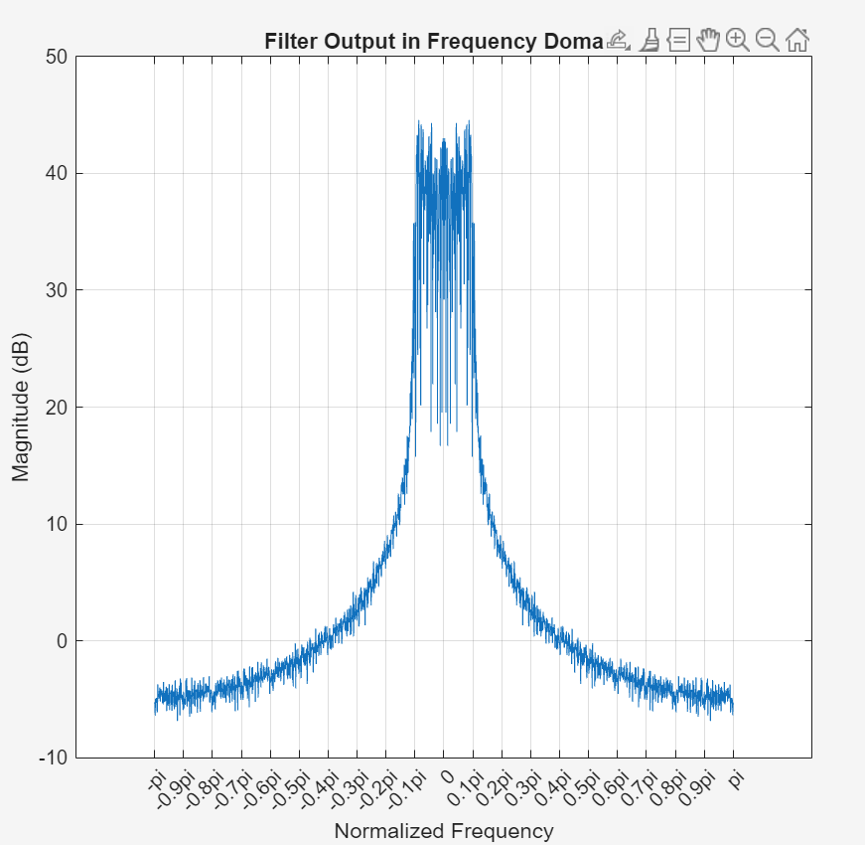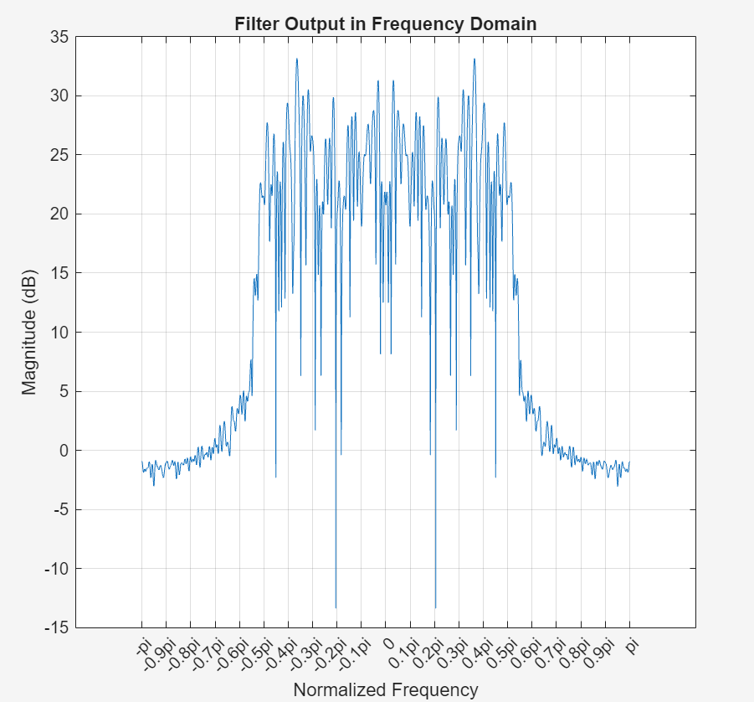
For L = 10
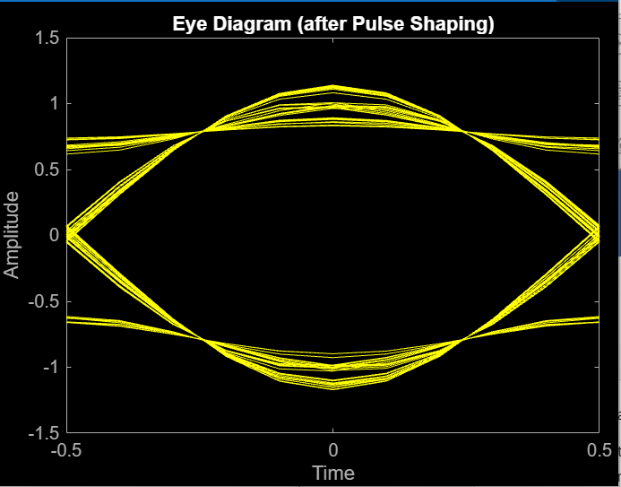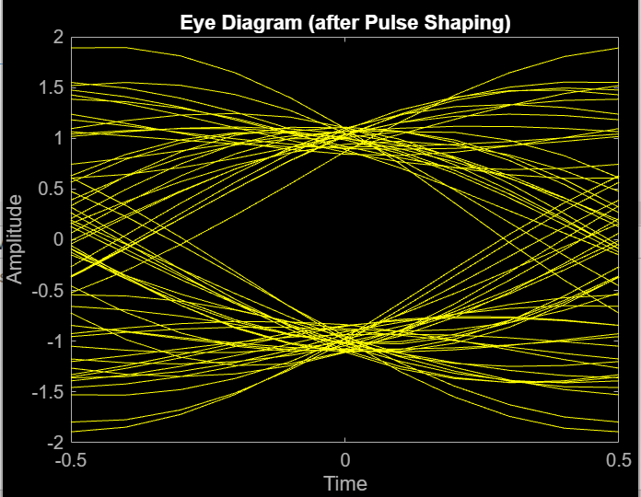
L = 100
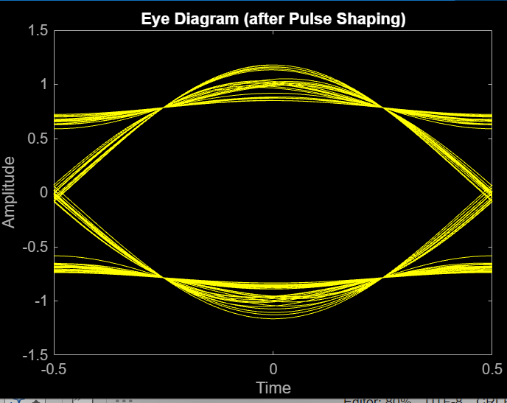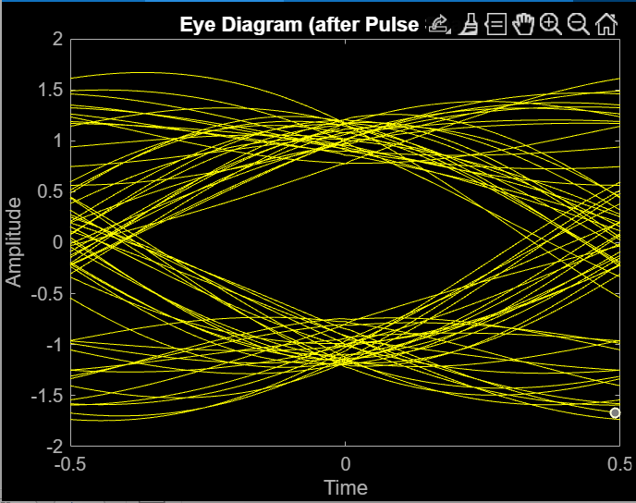
It doesn’t really look like increasing L affects the eye diagram.
M = number of independent phase points on our constellation. We can store log2(M) bits per symbol. I don’t yet know how this affects performance.

SPAN determines the order of the pulse shaping filter. A larger span will make cutoffs more abrupt. Filter order is = span*L .
SPAN = 5 (N = 50) SPAN = 20 (N=200)
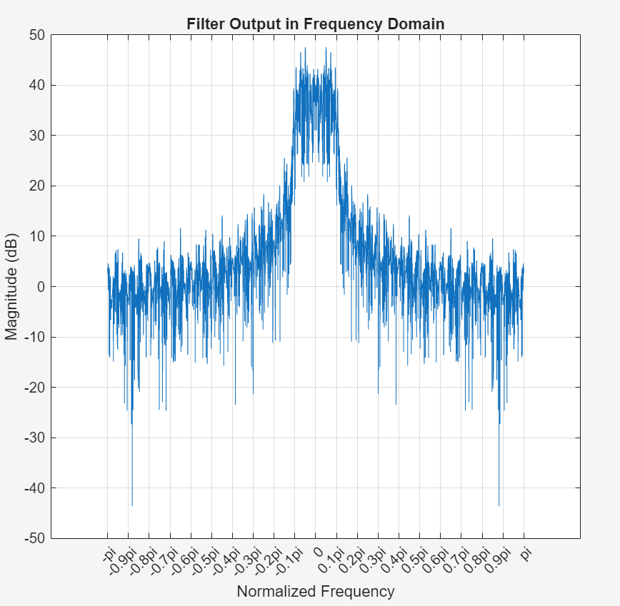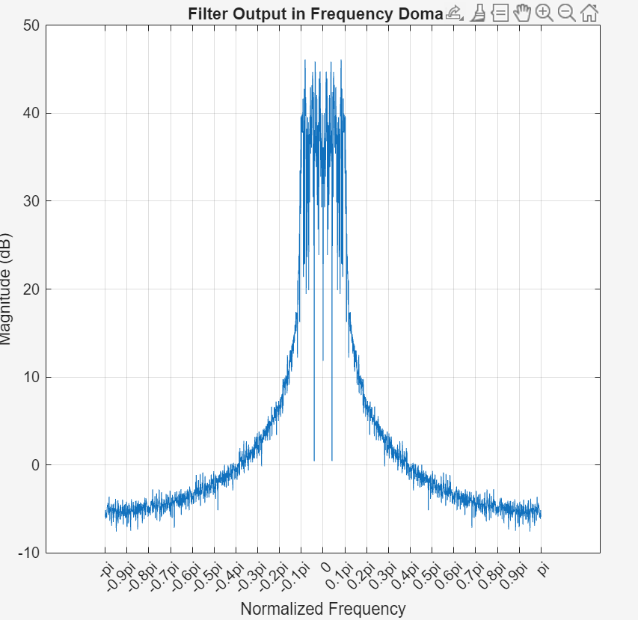
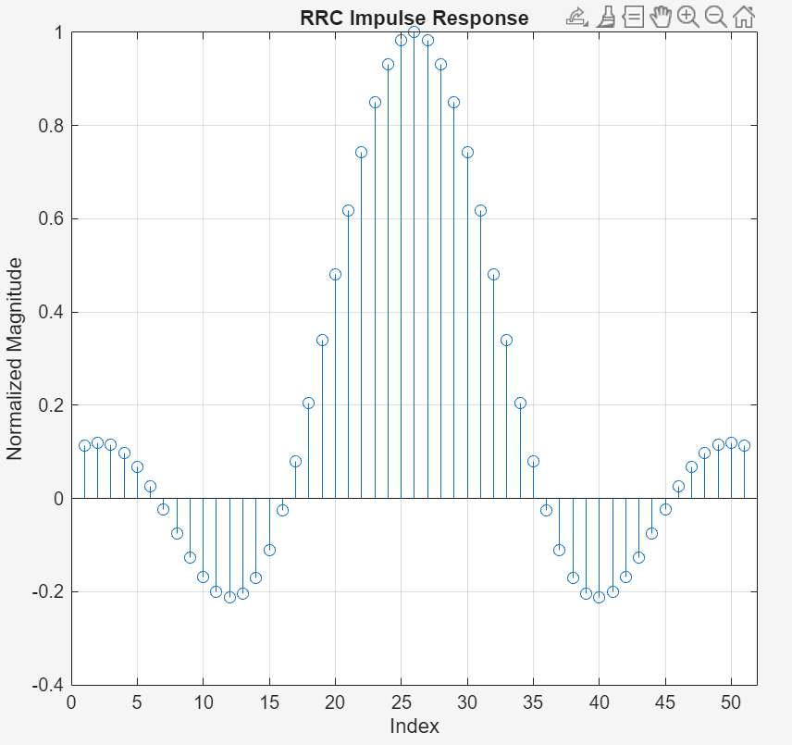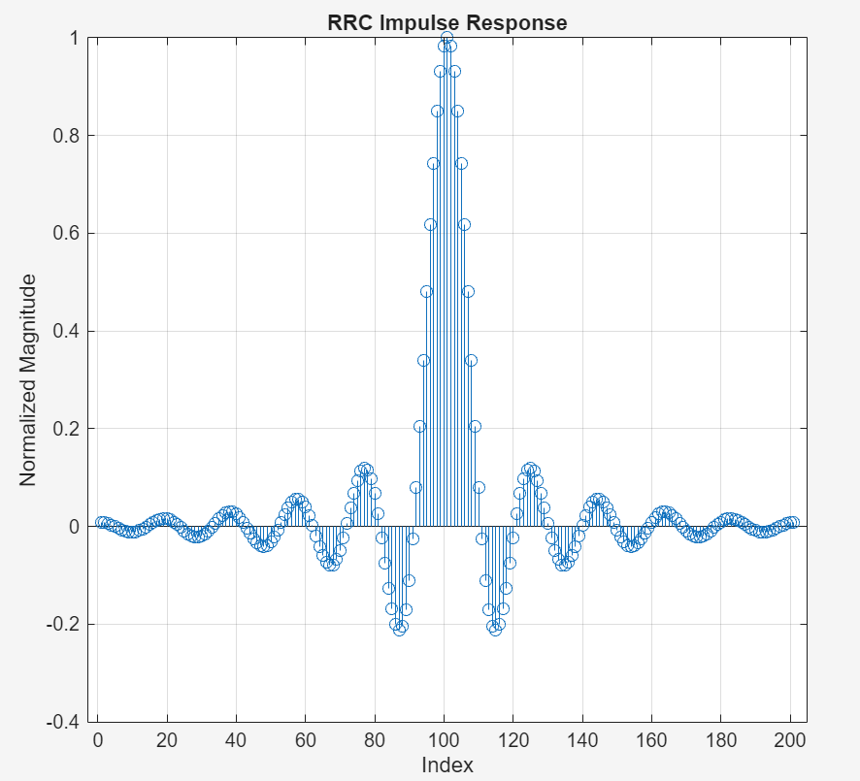

Rolloff is an input to the root raised cosine function. It determines the how rectangular or sinc like the function shape is. As rolloff -> 0, the RRC approaches a sinc function in time which is a rectangular function in frequency (zeros at +- Ts). Which is ideal, but only so far as we can represent many values of the sinc function. As rolloff -> 1, the RRC approaches a more tighter sinc shape (more rectangular) in time which approaches a wider mainlobe (zeros at +- 2Ts) in time with higher sidelobes. Thus, you take up more frequency space and have to deal with sidelobes interfering with adjacent signals.
Rolloff = 0
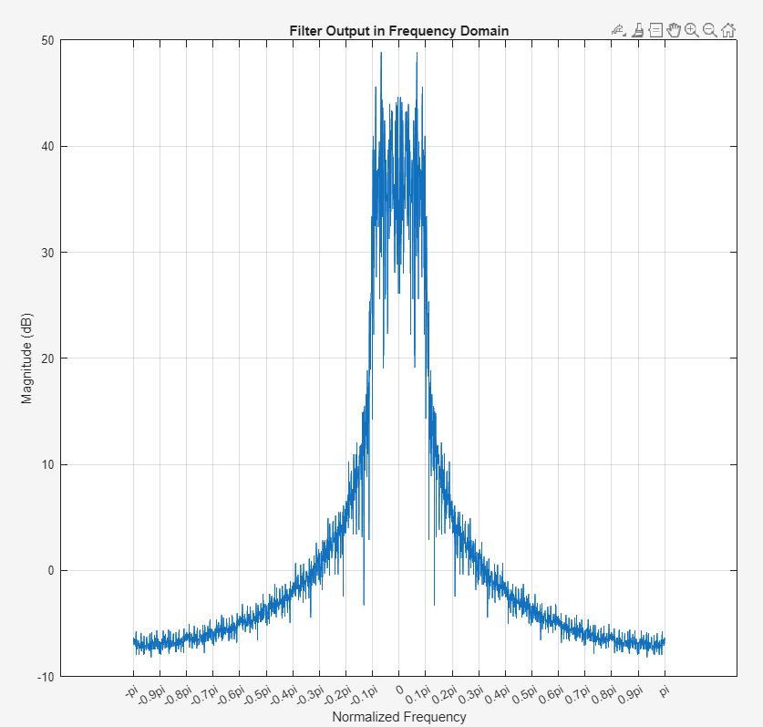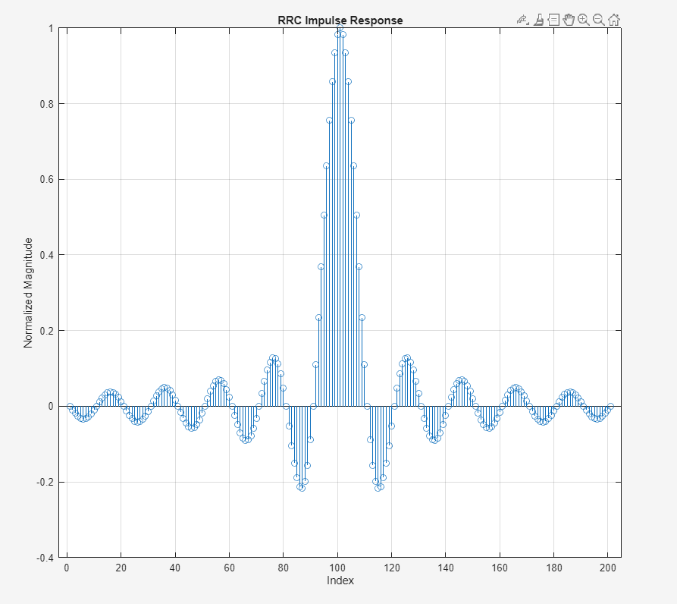
Rolloff = 0.5
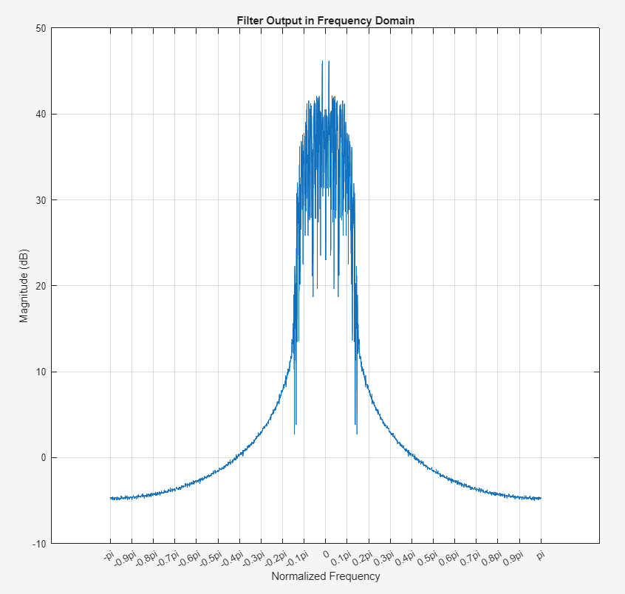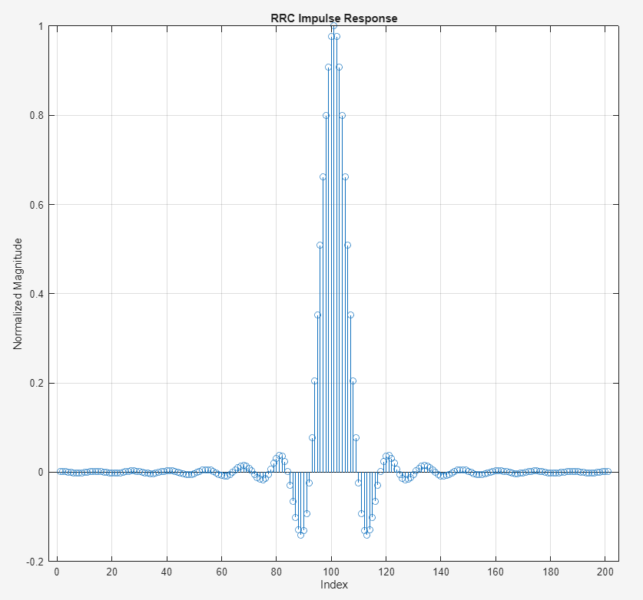

Rolloff = 1
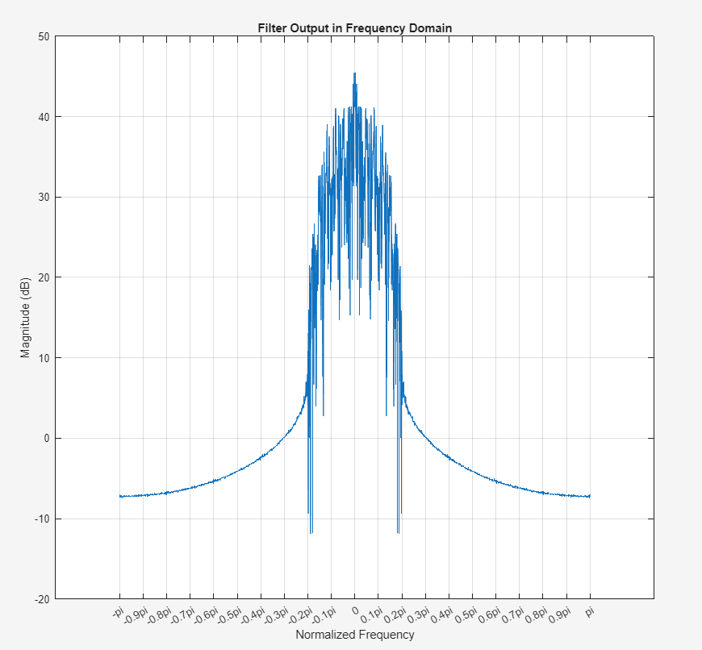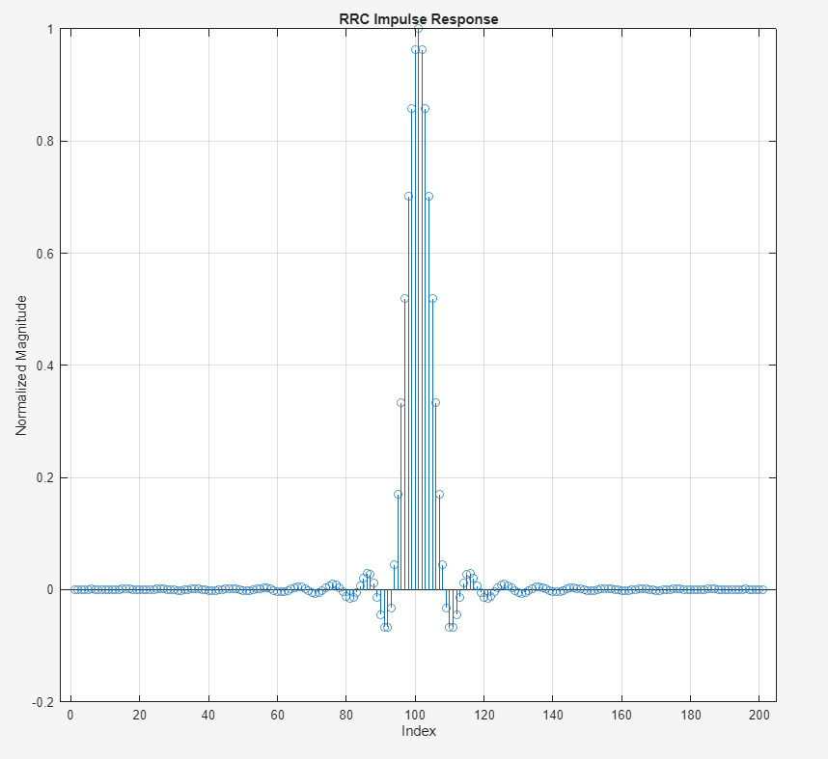
Rolloff = 0 Rolloff = 0.5
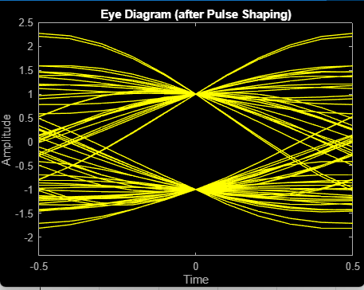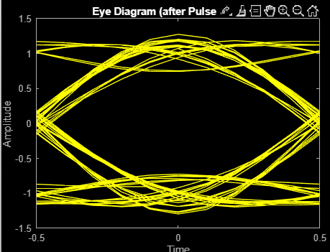
Rolloff = 1
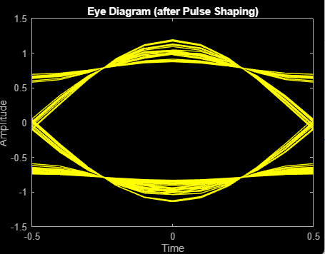
As the RRC function approaches sinc, our sample locations converge hard to points at mag = 1.
As the RRC function moves away from sinc, there is a bit more jitter in the sample location, which could make large amounts of noise problematic.

Questions:
- What kind of filter order would typically be used for pulse shaping. In class, a filter of N = 60 feels big. But here, to get good resolution on the Sinc function we could get up in the hundreds. Is that common.

- For the MPSK constellation, are there advantages to picking certain points over other points. I could pick points such that they ad all real or all complex components. Can we do anything with all complex points. I watched a video where a guy had an 8PSK constellation in a square. What do we gain or lose depending on the shape of our constellation.

- I plot the responses to the input of all the individual possible symbols. In thigher dimension PSK, the real values would as expected have different magnatudes and phases based on their position on the constellation. The response to complex sections were always the same. Is there a reason for this or is this just a matlab goof?

- How do I interpret the output plot as I get higher in dimension of PSK.
M = 4, Rolloff = 1 M = 4, Rolloff = 0
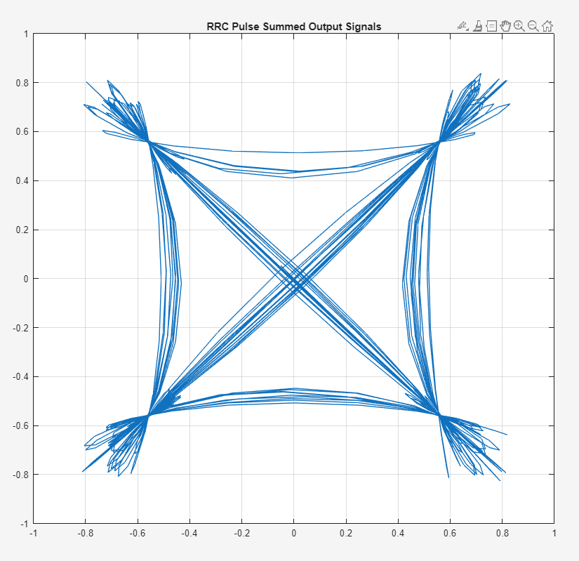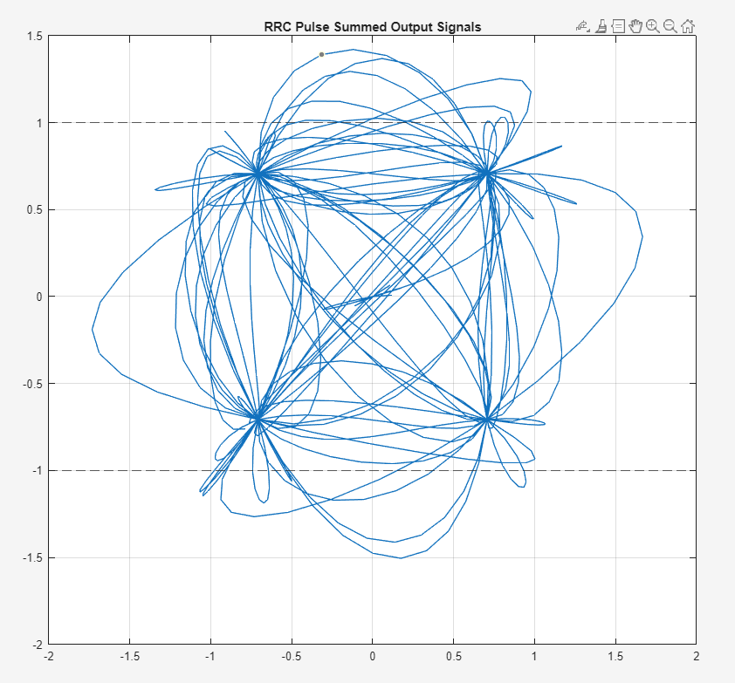

M = 8, Rolloff = 1
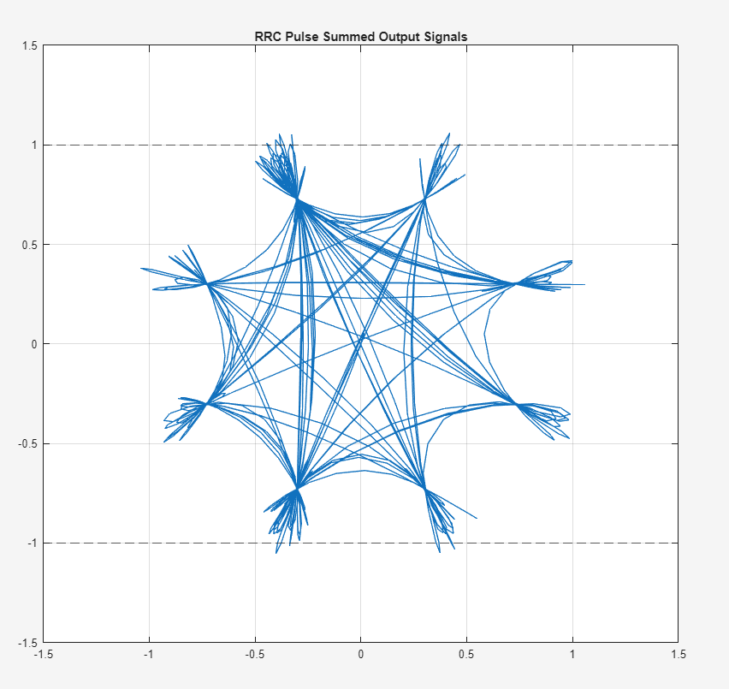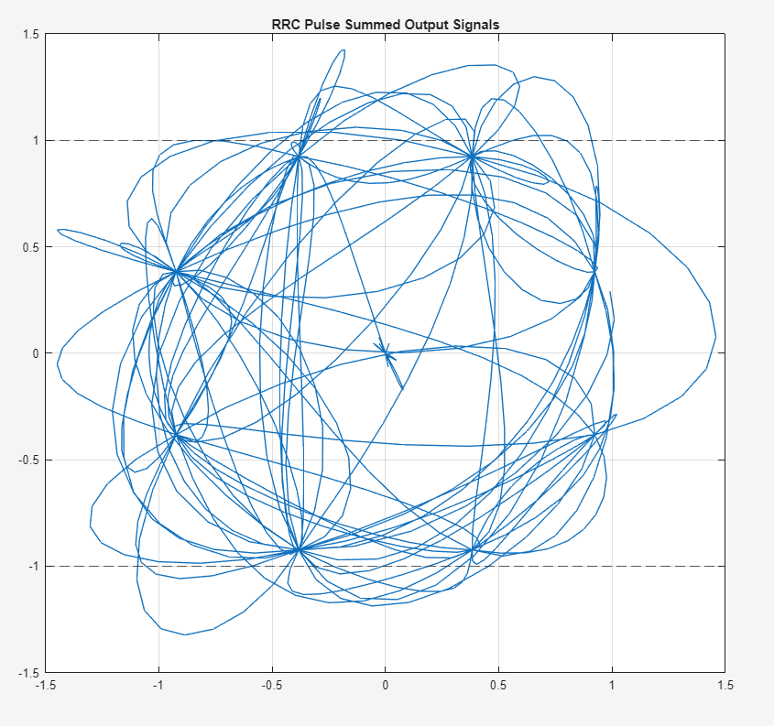

- There is a startup transient. How would we deal with that in practice.
M = 2
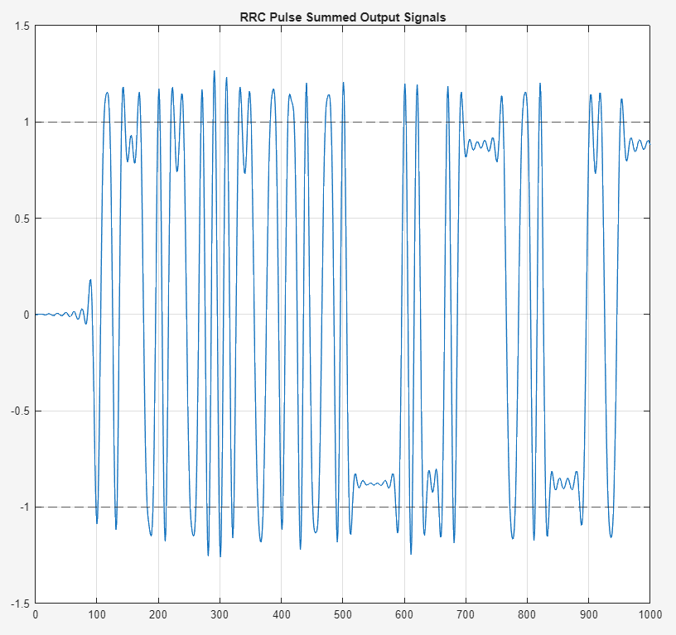

- How do we interpret the eye diagram for higher dimension PSK.
M = 16, rolloff = 0.99
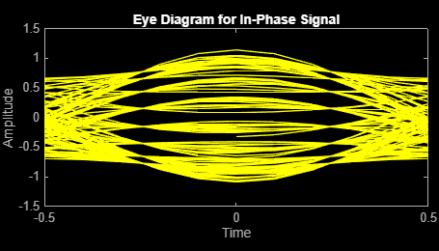
M = 8, rolloff = 0.99
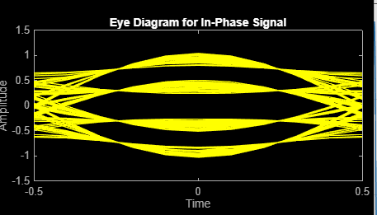

- Were in a system is this used?
- Where to from here? This all seemed to be on the transmitter side. Assuming we sent that signal our raw. How do I recover it. Matched filter?

